To
The Principal
---------------
----------------

Subject:- Invitation for Aura 2019 on the occasion of Quasquicentennial (125 yrs) celebration of Frances Newton Hospital .
Respected Sir/ Madam
Greeting from Frances Newton Hospital & School of Nursing. With Immense pleasure, this is to inform you that on behalf of Frances Newton Hospital Ferozepur organizes Aura 2019 on 22-02-2019. It is our delight that we cordially invite you, to participate & appoint your faculty members to attend the programme along with your Nursing Students (With Identification Card). The copy of programme schedule are enclosed here with.
Looking forward to meet you.
Kindly ensure your registration for Aura 2019 before 1st Feb. 2019. Registration fee of each person is Rs.300/-(Registration fee is nonrefundable). Registration can also be confirmed on the following contact numbers & email address.
- Mrs. Gulshanpreet M. No 9815427687
- Mr. Ashish Victor M.No 9814273420
- Email Id : nsgfnh@yahoo.com

Thanking You
With Regards
Director/ Medical Supdt.
Frances Newton Hospital

Enclosure:
- Copy of programme schedule of events
- Guidelines for programme events
- Staff/ Students entry performa

Note:- You are also cordially invited to attend “ Hospital Carnival 2019” on 24 Feb. 2019 from
10 am onwards with your nursing students (along with id- card)

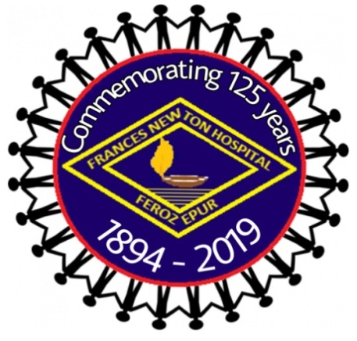
AURA 2019
AT
Frances Newton Hospital &School of Nursing
Ferozepur Cantt (pb)
Date:-22-02-2019

8:30 Am: Registration & Refreshment
9:30 Am: Inaugral Programmes.
- Prayer Song : Frances Newton Students
- Welcome dance : Frances Newton Students
- Introduction to chief guest : Chief Guest & dignitaries on the stage
- Inaugral Adress : Chief Guest
Time | Duration | Events | Co-Ordinators | Co-Ordinators | Venue
11 Am | 2 hrs | Collage Making | Mr. Ashish Victor | Mrs. Poonam | Class Room No. 5
11 Am | 2 hrs | Rangoli | Ms. Sukhbir Kr. | Mrs. Victoria | Class Room No. 4
11 Am | 1 Hrs. | Debate | Mrs.Gulshanpreet | Mr. Samuel Victor | Auditorium
12 MD | 30 Mins. | Quiz 1st Round & 2nd Round | Mr. Alisha Chauhan | Mr. Gourav | Auditorium
9:30Am |  | Volley ball for Boys | Mr. Vinay / Mr. Jaskaran | Mr. Waris | Kothi Lawn
12 MD | 7 Min for Each Team | Kho Kho for Girls | Mrs. Rajni Victor Mr. Jaskaran | Ms. Nishu | Kothi Lawn
1-2 PM | Launch Break
2 -4 PM |  | Group Dance (Bhangra,Western etc.) | Mr. Jasvir Singh | Ms. Sukhbir Kaur | Auditorium
- Prize Distribution & Valedictory

Guidelines For AURA 2018 Date:-22 Feb. 2019
- Collage making-
- One entry from each institution.(maximum 3 students)
- Topic will be given on the same day.
- Students must bring own material –charts, sketch colors, newspaper, magazines & paste material etc.

- Rangoli –
- One student from each institution will be allowed. (maximum 3 students)
- Bring your all material like rangoli colors, chalks etc.

- Debate-
- 2 candidates from each institution (in favour and against the topic).
- Topic will be given on the spot.
- 5 mintutes time allotted to each student.

- Quiz finals-
- 2 students from each institutions
- Areas of quiz are-sports, politics, music, movie, general aptitude etc.

- Volleyball –
- 2 pools-One team from each institution.

- Kho-Kho-
- One team from each institution.

- Group dance-
- Minimum 6 members
- One group from each institution
- Only one dance entry from a institution (Type of dance- Western/ eastern / bhangra)

--------------------------------

Name of Institute: - _______________________________________
Nursing Tutor/ Clinical Instructor
Accompanying with Students: - __________________________________________

Sr. No | Name of Students | Father’s Name | Institute Roll No./ Identity No. of Students | Course/ Class | Payment
 |  |  |  |  | Total Ammount

Note: - Register only those students who will participate in event.

Signature of Principal College/ School of Nursing
Institute Stamp

